Task 1: Concept Check

1.1 Packet processing from the NIC to the application, and promiscuous mode
When a packet reaches the Network Interface Card (NIC), it first checks the destination MAC address. If the address matches the NIC's own MAC address, a broadcast address, or a multicast group it has joined, the NIC accepts the frame and passes it to the operating system. The network driver copies the frame into kernel memory and notifies the kernel. The kernel then processes the packet layer by layer: the Ethernet layer checks the EtherType, the IP layer examines the Protocol field, and finally TCP or UDP uses the destination port number to deliver the data to the correct application.
In promiscuous mode, the NIC skips the MAC address check and accepts every frame it sees on the network, even if the packet is intended for another device. This is why packet sniffing tools can capture much more traffic when promiscuous mode is enabled.

1.2 Why not send every packet to user space, and kernel-level filtering
Sending every network packet to user space would waste a lot of system resources. Each packet must be copied from kernel memory to user memory, and this also requires a context switch between the kernel and the application. These operations consume CPU time and memory bandwidth.
On a busy network, most packets are not useful to the packet sniffer, so processing all of them can overload the system and even cause packet loss. To avoid this, the operating system uses kernel-level filtering, such as Berkeley Packet Filter (BPF). The filter runs inside the kernel and only forwards packets that match the specified rules. This reduces unnecessary copying, improves performance, and minimizes the chance of dropping important packets.

1.3 How the OS finds the right handler and application
The operating system uses information from different protocol headers to decide where each packet should go.
- The EtherType field in the Ethernet header identifies the network-layer protocol. For example:
  - 0x0800 → IPv4
  - 0x0806 → ARP
  - 0x86DD → IPv6
- If the packet is IPv4, the Protocol field identifies the transport-layer protocol:
  - 6 → TCP
  - 17 → UDP
  - 1 → ICMP
- Finally, TCP or UDP checks the destination port number to deliver the packet to the correct application or socket. For TCP, the operating system also considers the source IP address and source port so it can identify the correct connection.

1.4 Roles of snaplen, promisc, and to_ms in pcap_open_live()
The pcap_open_live() function uses several parameters to control packet capture:
- snaplen specifies the maximum number of bytes captured from each packet. If a packet is larger than this value, the remaining bytes are discarded. Using 2048 bytes is usually enough to capture complete packet headers.
- promisc determines whether the network interface operates in promiscuous mode. A value of 0 keeps the interface in normal mode, while any non-zero value enables promiscuous mode so packets intended for other devices can also be captured.
- to_ms is the read timeout (in milliseconds). It tells the kernel how long to wait before delivering captured packets to the application. Waiting briefly allows multiple packets to be sent together, improving efficiency.

1.5 Uses of a packet sniffer
Packet sniffers have both legitimate and malicious uses.
Legitimate uses:
- Network administrators use packet sniffers to troubleshoot network problems, identify slow connections, and diagnose configuration issues.
- Security professionals use them in intrusion detection and network monitoring systems to identify suspicious or unusual traffic.
Malicious uses:
- Attackers can capture sensitive information, such as usernames, passwords, and session cookies, if they are transmitted in plain text using protocols like HTTP, FTP, or Telnet.
- They can also monitor network activity and gather information about devices and services before carrying out further attacks.

Task 2: Basic Packet Capture
#include <stdio.h>
#include <stdlib.h>
#include <string.h>
#include <sys/types.h>
#include <pcap.h>
#include <arpa/inet.h>

typedef unsigned char u_char;

#define MAXBYTES 2048
#define ETH_HDR_LEN 14

struct packet_counter {
unsigned long count;
};

void process_pkt(u_char *args, const struct pcap_pkthdr *pkthdr, const u_char *packet);

int main(int argc, char **argv)
{
char errbuff[PCAP_ERRBUF_SIZE];
pcap_t *descptr = NULL;
char *devname = NULL;
struct packet_counter pc = {0};

if (argc > 1) {
devname = argv[1];
printf("[*] Using interface from command line: %s\n", devname);
} else {
devname = pcap_lookupdev(errbuff);
if (devname == NULL) {
fprintf(stderr, "[-] Error finding device: %s\n", errbuff);
return 1;
}
printf("[*] Found default device: %s\n", devname);
}

descptr = pcap_open_live(devname, MAXBYTES, 1, 1000, errbuff);
if (descptr == NULL) {
fprintf(stderr, "[-] Error opening device %s: %s\n", devname, errbuff);
return 1;
}
printf("[*] Interface opened successfully in promiscuous mode.\n");

printf("[*] Starting packet capture...\n\n");
if (pcap_loop(descptr, 50, process_pkt, (u_char *)&pc) < 0) {
fprintf(stderr, "[-] Pcap loop error: %s\n", pcap_geterr(descptr));
pcap_close(descptr);
return 1;
}

pcap_close(descptr);
return 0;
}

void process_pkt(u_char *args, const struct pcap_pkthdr *pkthdr, const u_char *packet)
{
struct packet_counter *pc = (struct packet_counter *)args;
pc->count++;

printf("Packet #%lu time: %ld.%06ld caplen: %u len: %u\n",
pc->count,
(long)pkthdr->ts.tv_sec,
(long)pkthdr->ts.tv_usec,
pkthdr->caplen,
pkthdr->len);

}

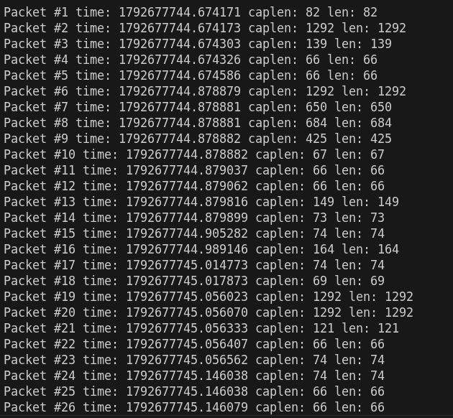
Observation: The screenshot for Task 2 shows the sniffer running on interface eth0 in promiscuous mode. Every captured packet is printed with its packet number, capture timestamp, caplen and len. caplen is equal to len for all packets because the snaplen of 2048 bytes is larger than every captured frame (the largest here is 1292 bytes), so no packet was truncated. The packet counter is incremented inside the callback through the user argument, and the capture stops automatically after 50 packets because pcap_loop() is called with count = 50.

Task 3: Ethernet Header Dissection
#define ETH_HDR_LEN 14 /* Ethernet header is always 14 bytes */
#define ETH_DST_OFFSET 0 /* destination MAC starts at byte 0 */
#define ETH_SRC_OFFSET 6 /* source MAC starts at byte 6 */
#define ETH_TYPE_OFFSET 12 /* EtherType starts at byte 12 */

#define ETHERTYPE_IPV4 0x0800 /* payload is an IPv4 datagram */
#define ETHERTYPE_ARP 0x0806 /* payload is an ARP message */
#define ETHERTYPE_IPV6 0x86DD /* payload is an IPv6 datagram */

/* Running frame-type counters, printed when the capture ends (Task 3.3) */
static unsigned long eth_ipv4_count = 0;
static unsigned long eth_arp_count = 0;
static unsigned long eth_ipv6_count = 0;
static unsigned long eth_other_count = 0;

/* print_mac: prints the 6 bytes starting at mac[0] in AA:BB:CC:DD:EE:FF form.
* %02X prints each byte as two upper-case hex digits with a leading zero. */
void print_mac(const u_char *mac)
{
printf("%02X:%02X:%02X:%02X:%02X:%02X",
mac[0], mac[1], mac[2], mac[3], mac[4], mac[5]);
}

/* dissect_ethernet: decodes and prints the Ethernet header of one frame,
* updates the frame-type counters and returns the EtherType, so the
* IPv4 module (Task 4) knows whether to decode the payload.
* Returns 0 if the captured frame is shorter than an Ethernet header. */
unsigned short dissect_ethernet(const u_char *packet, unsigned int caplen)
{
unsigned short eth_type;

/* Safety check: never read past the bytes that were actually captured */
if (caplen < ETH_HDR_LEN) {
printf(" [Ethernet] frame too short (%u bytes)\n", caplen);
eth_other_count++;
return 0;
}

/* Destination MAC: bytes 0-5 */
printf(" [Ethernet] Dst MAC: ");
print_mac(packet + ETH_DST_OFFSET);

/* Source MAC: bytes 6-11 */
printf(" Src MAC: ");
print_mac(packet + ETH_SRC_OFFSET);
printf("\n");

/* EtherType: bytes 12-13. Network byte order is big-endian, so byte 12
* is the high byte: shift it left 8 bits and OR in byte 13.
* Example: 08 00 -> (0x08 << 8) | 0x00 = 0x0800 (IPv4). */
eth_type = (unsigned short)((packet[ETH_TYPE_OFFSET] << 8) | packet[ETH_TYPE_OFFSET + 1]);

/* Print the meaning of the EtherType and update the matching counter */
printf(" [Ethernet] Type: 0x%04X ", eth_type);
switch (eth_type) {
case ETHERTYPE_IPV4: printf("(IPv4)\n"); eth_ipv4_count++; break;
case ETHERTYPE_ARP: printf("(ARP)\n"); eth_arp_count++; break;
case ETHERTYPE_IPV6: printf("(IPv6)\n"); eth_ipv6_count++; break;
default: printf("(Other)\n"); eth_other_count++; break;
}

return eth_type;
}

/* print_ethernet_stats: prints the frame-type counters; called from main()
* after pcap_loop() returns, i.e. when the capture ends (Task 3.3). */
void print_ethernet_stats(void)
{
printf("\n===== Ethernet frame-type summary =====\n");
printf("IPv4 : %lu\n", eth_ipv4_count);
printf("ARP : %lu\n", eth_arp_count);
printf("IPv6 : %lu\n", eth_ipv6_count);
printf("Other : %lu\n", eth_other_count);
printf("Total : %lu\n",
eth_ipv4_count + eth_arp_count + eth_ipv6_count + eth_other_count);
}
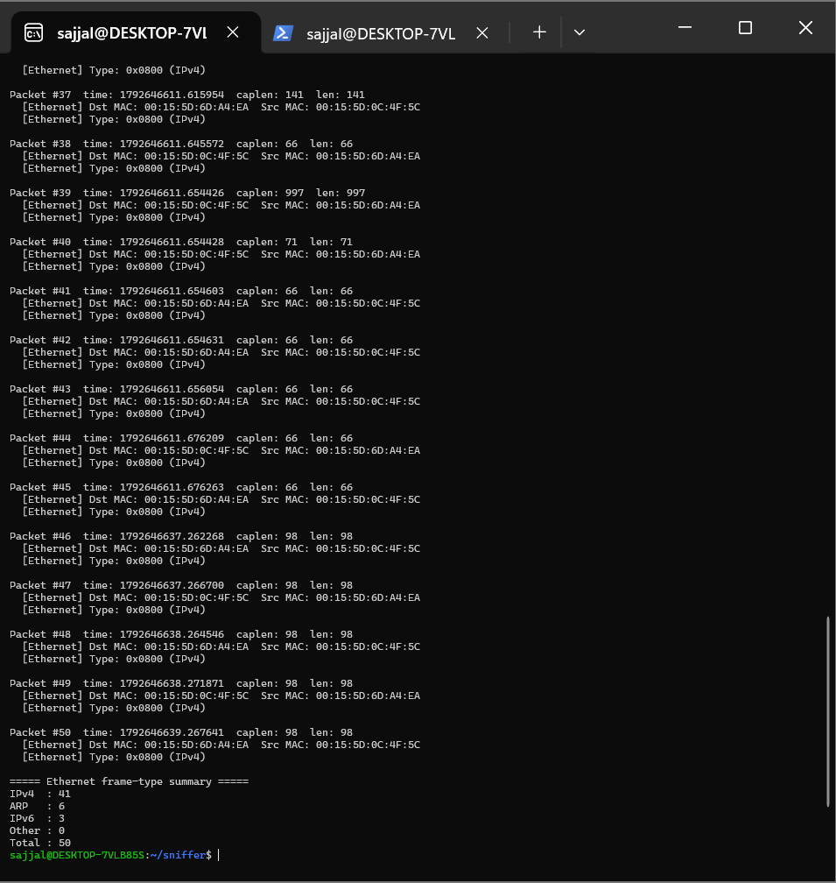

Observation: The screenshot for Task 3 shows the output after we ran the sniffer on eth0 and created traffic from a second terminal using ping, curl and nslookup. In almost every frame the two MAC addresses swap places between 00:15:5D:0C:4F:5C, which is our own WSL interface, and 00:15:5D:6D:A4:EA, the virtual gateway, because each request and its reply were captured as separate frames. The capture stopped after 50 packets and the counters showed 41 IPv4, 6 ARP, 3 IPv6 and 0 Other frames. Most of the frames were IPv4 because all three test commands used IPv4, while the ARP frames came from the machine looking up the MAC address of the gateway. The 3 IPv6 frames were background traffic generated by the system itself, not by our test commands.

Task 4: IPv4 Header Dissection
#include <stdio.h>
#include <string.h>
#include <arpa/inet.h>

typedef unsigned char u_char;

int dissect_ipv4(const u_char *ip)
{
int version = ip[0] >> 4;
int ihl = ip[0] & 0x0F;
int hdr_len = ihl * 4;

unsigned short total_len = ntohs(*(const unsigned short *)(ip + 2));

unsigned short id = ntohs(*(const unsigned short *)(ip + 4));

unsigned short ff = ntohs(*(const unsigned short *)(ip + 6));
int df = (ff & 0x4000) != 0;
int mf = (ff & 0x2000) != 0;
int frag_offset = ff & 0x1FFF;

int ttl = ip[8];
int proto = ip[9];

unsigned short checksum = ntohs(*(const unsigned short *)(ip + 10));

char src[16], dst[16];
snprintf(src, sizeof src, "%d.%d.%d.%d", ip[12], ip[13], ip[14], ip[15]);
snprintf(dst, sizeof dst, "%d.%d.%d.%d", ip[16], ip[17], ip[18], ip[19]);

printf(" --- IPv4 Header ---\n");
printf(" Version : %d\n", version);
printf(" IHL : %d words (%d bytes)\n", ihl, hdr_len);
printf(" Total Length : %u bytes\n", total_len);
printf(" Identification : 0x%04X\n", id);
printf(" Flags : DF=%s, MF=%s\n", df ? "set" : "not set", mf ? "set" : "not set");
printf(" Fragment Offset: %d (byte offset %d)\n", frag_offset, frag_offset * 8);
printf(" TTL : %d\n", ttl);
printf(" Protocol : %d (%s)\n", proto,
proto == 6 ? "TCP" : proto == 17 ? "UDP" : "Other");
printf(" Checksum : 0x%04X\n", checksum);
printf(" Source IP : %s\n", src);
printf(" Destination IP : %s\n", dst);

return hdr_len;
}

int main(void)
{
u_char frame[] = {
0x00,0x1A,0x2B,0x3C,0x4D,0x5E,0x08,0x00,0x27,0xAA,0xBB,0xCC,0x08,0x00,
0x45,0x00,0x00,0x28,0x1C,0x46,0x40,0x00,0x40,0x06,0x26,0xFD,
0xC0,0xA8,0x01,0x0A,0x5D,0xB8,0xD8,0x22,
0xC3,0x50,0x00,0x50,0x00,0x00,0x03,0xE8,0x00,0x00,0x00,0x00,
0x50,0x02,0x72,0x10,0x1A,0x2B,0x00,0x00
};
dissect_ipv4(frame + 14);
return 0;
}

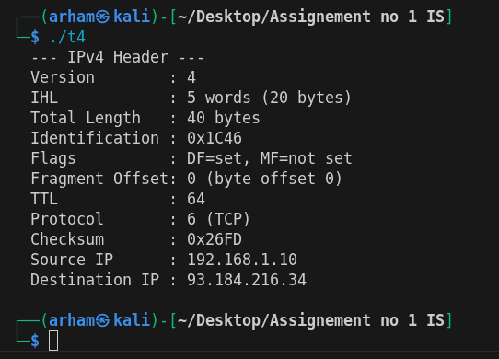
Observation: The screenshot for Task 4 shows the IPv4 dissector decoding the 54-byte test frame: Version 4, IHL 5 words (20 bytes), Total Length 40 bytes, Identification 0x1C46, DF set, MF not set, fragment offset 0, TTL 64, Protocol 6 (TCP), Checksum 0x26FD, source 192.168.1.10 and destination 93.184.216.34. In the integrated sniffer the same function runs on every frame whose EtherType is 0x0800, and the IHL field is used to find the start of the transport header, so a fixed 20-byte header is not assumed. For live traffic the Protocol field is 1 for ping (ICMP, printed as Other), 6 for curl (TCP) and 17 for nslookup (UDP), and the TTL of packets sent from our own Linux machine is 64

Task 5: TCP and UDP Header Dissection
#include <stdio.h>
#include <string.h>
#include <arpa/inet.h>

typedef unsigned char u_char;

const char *port_to_app(int port)
{
switch (port) {
case 80: return "HTTP (web)";
case 25: return "SMTP (email)";
case 20:
case 21: return "FTP";
case 53: return "DNS";
case 443: return "HTTPS";
case 22: return "SSH";
case 23: return "Telnet";
default: return NULL;
}
}

static void print_app(int sport, int dport)
{
const char *a = port_to_app(dport);
if (!a) a = port_to_app(sport);
printf(" Application : %s\n", a ? a : "Unknown");
}

void dissect_transport(const u_char *packet, int ip_hdr_len, int proto)
{
const u_char *t = packet + 14 + ip_hdr_len;

int sport = (t[0] << 8) | t[1];
int dport = (t[2] << 8) | t[3];

if (proto == 6) {
unsigned int seq = ((unsigned)t[4] << 24) | (t[5] << 16) | (t[6] << 8) | t[7];
unsigned int ack = ((unsigned)t[8] << 24) | (t[9] << 16) | (t[10] << 8) | t[11];

int words = t[12] >> 4;

int f = t[13];

printf(" --- TCP Header ---\n");
printf(" Source Port : %d\n", sport);
printf(" Dest Port : %d\n", dport);
printf(" Sequence No. : %u\n", seq);
printf(" Ack No. : %u\n", ack);
printf(" Header Length : %d words (%d bytes)\n", words, words * 4);
printf(" Flags :");
if (f & 0x20) printf(" URG");
if (f & 0x10) printf(" ACK");
if (f & 0x08) printf(" PSH");
if (f & 0x04) printf(" RST");
if (f & 0x02) printf(" SYN");
if (f & 0x01) printf(" FIN");
printf("\n");
print_app(sport, dport);
}
else if (proto == 17) {
int len = (t[4] << 8) | t[5];
int chk = (t[6] << 8) | t[7];

printf(" --- UDP Header ---\n");
printf(" Source Port : %d\n", sport);
printf(" Dest Port : %d\n", dport);
printf(" Length : %d bytes\n", len);
printf(" Checksum : 0x%04X\n", chk);
print_app(sport, dport);
}
}

int main(void)
{
u_char tcp_frame[] = {
0x00,0x1A,0x2B,0x3C,0x4D,0x5E,0x08,0x00,0x27,0xAA,0xBB,0xCC,0x08,0x00,
0x45,0x00,0x00,0x28,0x1C,0x46,0x40,0x00,0x40,0x06,0x26,0xFD,
0xC0,0xA8,0x01,0x0A,0x5D,0xB8,0xD8,0x22,
0xC3,0x50,0x00,0x50,0x00,0x00,0x03,0xE8,0x00,0x00,0x00,0x00,
0x50,0x02,0x72,0x10,0x1A,0x2B,0x00,0x00
};
printf("TCP test (Task 6 frame):\n");
dissect_transport(tcp_frame, 20, 6);

u_char udp_frame[14 + 20 + 8] = {0};
udp_frame[14] = 0x45; udp_frame[14 + 9] = 17;
u_char *u = udp_frame + 34;
u[0] = 0xD4; u[1] = 0x31;
u[2] = 0x00; u[3] = 0x35;
u[4] = 0x00; u[5] = 0x20;
u[6] = 0x12; u[7] = 0x34;
printf("\nUDP test (DNS):\n");
dissect_transport(udp_frame, 20, 17);
return 0;
}
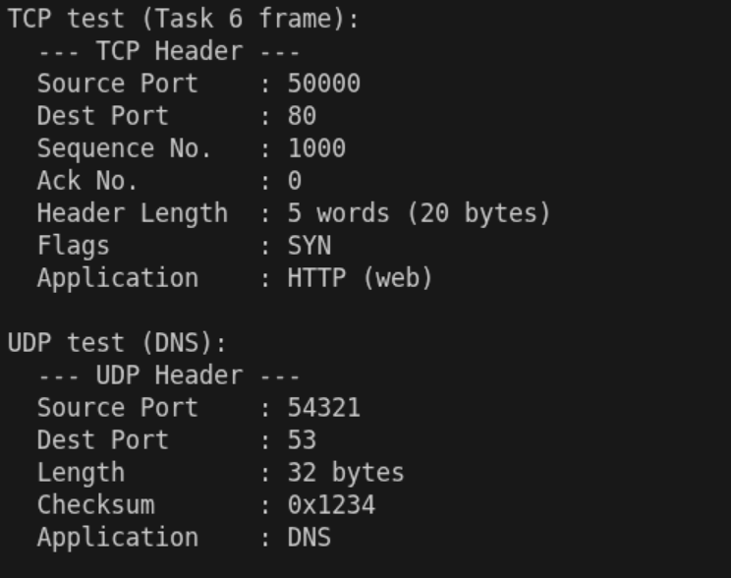
Observation: The screenshot for Task 5 shows the TCP dissector on the test frame (source port 50000, destination port 80, sequence number 1000, acknowledgement number 0, header length 5 words = 20 bytes, flag SYN) with destination port 80 guessed as HTTP (web), and the UDP dissector on a DNS-style datagram (source port 54321, destination port 53, length 32 bytes, checksum 0x1234) guessed as DNS. In a real curl session the flags show the handshake: SYN, then SYN with ACK, then ACK, and later ACK with PSH for the data. The client uses a random high source port such as 50000, while the server port stays fixed (80 for HTTP, 53 for DNS).

Task 6: Manual Packet Decoding
Ethernet header (bytes 0-13)
Field | Bytes | Hex | Decoded
Destination MAC | 0-5 | 00 1A 2B 3C 4D 5E | 00:1A:2B:3C:4D:5E
Source MAC | 6-11 | 08 00 27 AA BB CC | 08:00:27:AA:BB:CC
EtherType | 12-13 | 08 00 | 0x0800 = IPv4

IPv4 header (bytes 14-33)
Field | Bytes | Hex | Decoded
Version / IHL | 14 | 45 | Version 4, IHL 5 words = 20 bytes
Total Length | 16-17 | 00 28 | 40 bytes (20 IP + 20 TCP)
Identification | 18-19 | 1C 46 | 0x1C46
Flags / Frag offset | 20-21 | 40 00 | DF set (0x4000), MF not set, offset 0
TTL | 22 | 40 | 64
Protocol | 23 | 06 | 6 = TCP
Checksum | 24-25 | 26 FD | 0x26FD
Source IP | 26-29 | C0 A8 01 0A | 192.168.1.10
Destination IP | 30-33 | 5D B8 D8 22 | 93.184.216.34

TCP header (start = 14 + 20 = byte 34)
Field | Bytes | Hex | Decoded
Source port | 34-35 | C3 50 | 50000
Destination port | 36-37 | 00 50 | 80
Sequence number | 38-41 | 00 00 03 E8 | 1000
Ack number | 42-45 | 00 00 00 00 | 0
Header length / flags | 46-47 | 50 02 | Data offset 5 words = 20 bytes; flags byte 0x02 = 00000010, so only SYN
Window | 48-49 | 72 10 | 29200
Checksum / Urgent | 50-53 | 1A 2B 00 00 | 0x1A2B / 0
Answers
- Destination MAC: 00:1A:2B:3C:4D:5E, Source MAC: 08:00:27:AA:BB:CC, EtherType: 0x0800 = IPv4.
- IP Version: 4, Header Length: 20 bytes, Total Length: 40 bytes, TTL: 64, Protocol: 6 (TCP), Source IP: 192.168.1.10, Destination IP: 93.184.216.34.
- The DF (Don't Fragment) flag is set, the MF (More Fragments) flag is not set, and the Fragment Offset is 0, which means the packet is not fragmented.
- Source Port: 50000, Destination Port: 80, Sequence Number: 1000, TCP Header Length: 20 bytes, and only the SYN flag is set.
- This is the first packet of the TCP three-way handshake. The client is requesting to establish a connection with the server (SYN), no data is being transmitted, and the ACK number is 0. Port 80 is used for HTTP (web) traffic.

We ran our dissection functions on the byte values of this frame. The program output (see the Task 5 screenshot, “TCP test (Task 6 frame)”) shows source port 50000, destination port 80, sequence number 1000, acknowledgement number 0, header length 20 bytes and flag SYN, which matches the manual decoding above.

5. Contribution statement
Member | Name / Roll No. | Module owned | Tasks completed | Effort % | Signature
1 (Leader) |  | Capture engine and integration | Task 2, merging, Tasks 1 and 6 | 25%
2 |  | Ethernet dissection | Task 3, Tasks 1 and 6 | 25%
3 | Muhammad Arham  L1F23BSSE0372 | IPv4 dissection | Task 4, Tasks 1 and 6 | 25%
4 | Muzaffar Ali  L1F23BSSE0395 | TCP/UDP dissection | Task 5, Tasks 1 and 6 | 25%

6: Peer-review notes
Reviewer | Module reviewed | One improvement
Member 1: Handle VLAN-tagged frames (EtherType 0x8100), which are currently counted as Other. | Member 1: Handle VLAN-tagged frames (EtherType 0x8100), which are currently counted as Other. | Member 1: Handle VLAN-tagged frames (EtherType 0x8100), which are currently counted as Other.
Member 2: Verify the IPv4 header checksum and print a warning when IHL is greater than 5 (IP options). | Member 2: Verify the IPv4 header checksum and print a warning when IHL is greater than 5 (IP options). | Member 2: Verify the IPv4 header checksum and print a warning when IHL is greater than 5 (IP options).
Member 3: Add more well-known ports (for example 110 POP3, 143 IMAP, 3306 MySQL) and handle ICMP instead of printing it only as Other. | Member 3: Add more well-known ports (for example 110 POP3, 143 IMAP, 3306 MySQL) and handle ICMP instead of printing it only as Other. | Member 3: Add more well-known ports (for example 110 POP3, 143 IMAP, 3306 MySQL) and handle ICMP instead of printing it only as Other.
Member 4: Replace the deprecated pcap_lookupdev() with pcap_findalldevs(), and stop cleanly on Ctrl+C using pcap_breakloop() so the summary is always printed. | Member 4: Replace the deprecated pcap_lookupdev() with pcap_findalldevs(), and stop cleanly on Ctrl+C using pcap_breakloop() so the summary is always printed. | Member 4: Replace the deprecated pcap_lookupdev() with pcap_findalldevs(), and stop cleanly on Ctrl+C using pcap_breakloop() so the summary is always printed.

